**Assembly Meeting**

* Using mechanical analogs for chips?
* Use fluorescence chips aren’t working … Don’t have any that are the correct dimensions.
* **Where are the solid models?**
* Spacer, PCB, spacer, chip ?
* Spacing: 4,2,4,2,4,2.

**MIC Chips:**

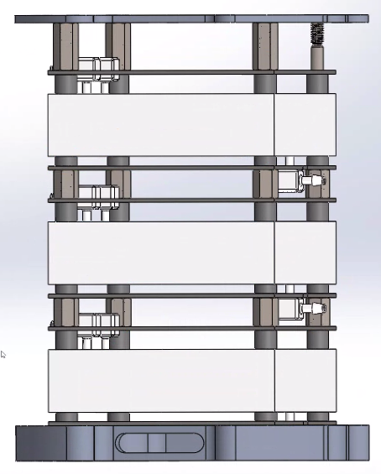“Lid”

10mm

4mm

2mm

Standoffs: 6mm, can be spacers.

“Bracket”

Single Threaded rods on corners, Tareq cut.

**Waste Compartment:**

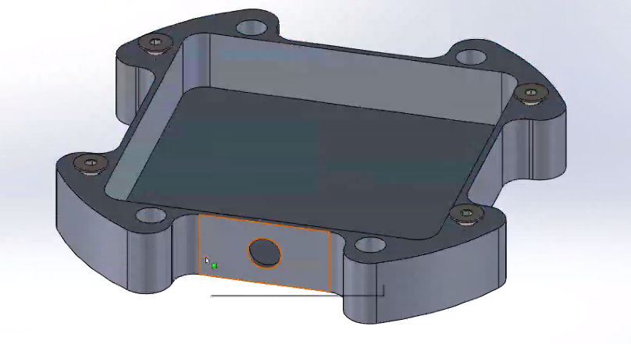

* Chain of connections completes at the waste compartment.
* **How does fluid work if none of the chips can hold fluid?**

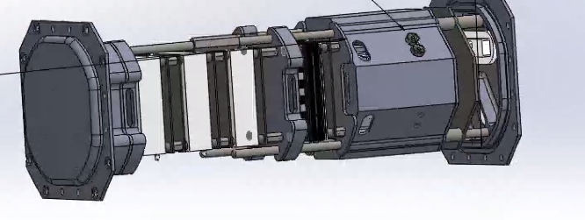

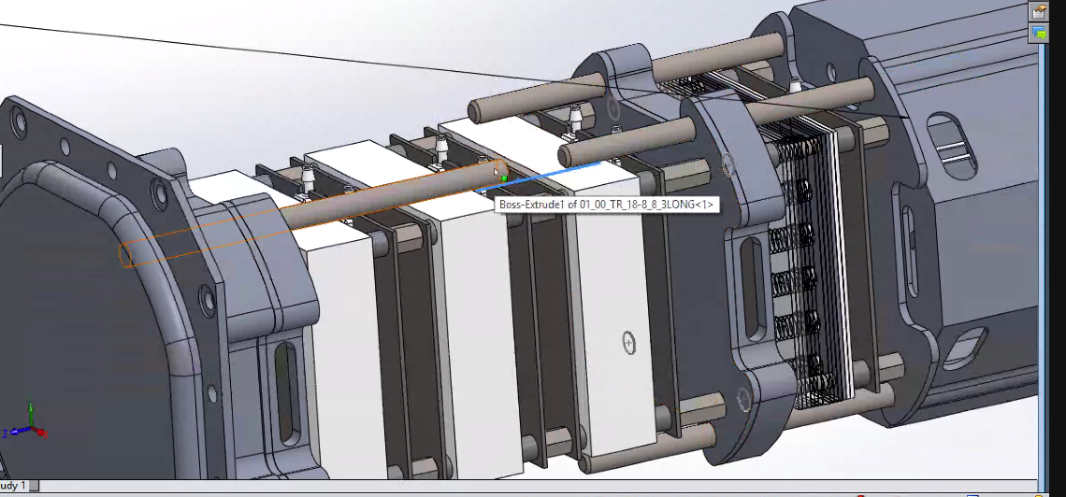

* Viton on what?
* **1 inch standoff to connect 8 inch and 3 inch threaded rods.**
* Rails all follow the same idea.
* M3 to put in rails.
* **Each of the four rails is slightly different.**
* **Compare 3D printed rails to Aluminum rails.**

**Deployment Switch + Rail:**

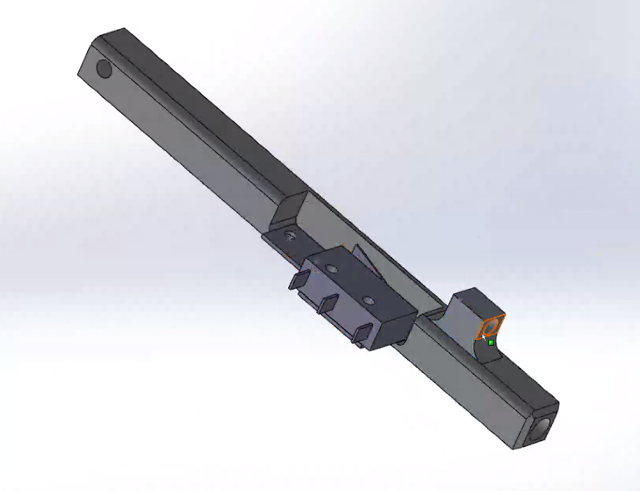

**Spring & tab comes out bottom, Threads in threaded rod and depresses the microswitch.**

* ***Do we have these deployment switches?
* Edges on the bus strut are rounded.
* Deployment switch rails – rounded corners.
* **M3 all except for holes to mount secondary structure.**
* M3 already have helicoil.
* Need to put in helicoils for M2.5
* Need: M2.5 insertion tool.
* Interior payload struts
* One of the struts doesn’t have holes on the top and bottom faces.
* Look at 3D printed version to figure out what goes where.
* Electronics Assembly:

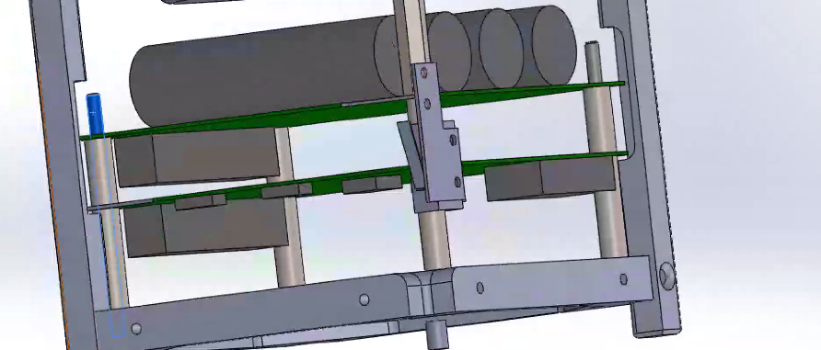

10mm and 3 viton spacers

20mm

**Hole Mover:**

